Tech Note: WebSphere Liberty Collective Clusters — Session Replication and Controller Replication
Oct 27, 2026 · @Saravanan Kuppusamy

Overview
Liberty replicates two different things, by two different mechanisms. Session data between cluster members is replicated by a session persistence feature you add to each member (a shared database or a JCache in-memory grid). Collective repository data between controllers is replicated automatically once the controllers form a replica set.
Key terms:
- Collective — the set of Liberty servers in one administrative domain.
- Collective controller — a server with collectiveController-1.0 (Network Deployment only). Holds the operational repository; routes MBeans, file transfer and cluster management.
- Collective member — a server with collectiveMember-1.0 that has joined a controller.
- Cluster — members with clusterMember-1.0 sharing the same <clusterMember name="..."/>. The controller tracks membership; it does not replicate sessions.
- Replica set — an odd number (3 minimum for HA) of co-equal controllers that replicate the repository to each other. No primary or secondary.
Scope: examples use Windows paths and .bat commands to match a single-host class lab (one machine, unique ports per server). On separate hosts you can keep the same ports on every server.
Assumed layout for every example below:
Server | Role | HTTP / HTTPS | Replica port
controller1 | Initial controller | 9080 / 9443 | 10010
controller2 | Replica | 9081 / 9444 | 10011
controller3 | Replica | 9082 / 9445 | 10012
member1 | Cluster member of AppCluster | 9180 / 9543 | —
member2 | Cluster member of AppCluster | 9181 / 9544 | —
Install root is C:\wlp; admin user admin / adminpwd; keystore password Liberty. Change all of these for anything beyond a lab.
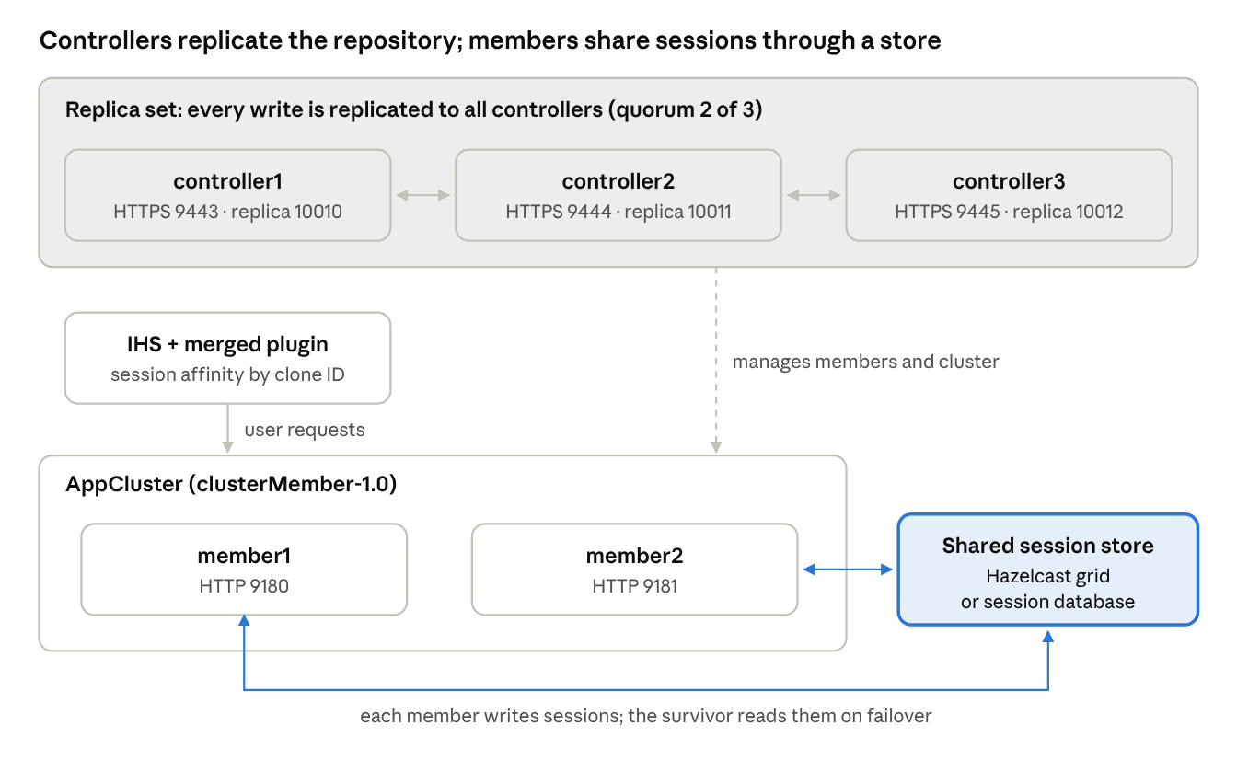
lab topology · 3 controllers, 2 cluster members, 1 session store
The controllers never carry session data: the top box is Part 2, the bottom row is Part 1.

Part 1 — Replicating session data between cluster members
Liberty has no tWAS-style memory-to-memory (DRS) replication. Sessions survive a member failure only when every member writes them to a shared store that the other members can read. Pick one:
Option | Feature | Where sessions live | Best for
Database persistence | sessionDatabase-1.0 | Shared RDBMS table | Simple, durable; adds DB latency
JCache in-memory grid | sessionCache-1.0 | Hazelcast or Infinispan, peer-to-peer across members | Fast; the closest thing to memory-to-memory
WebSphere eXtreme Scale | WXS client features | External data grid | Sites already licensed for WXS
In all cases, keep session affinity at the router (IHS plugin or dynamic routing): requests stick to one member, and the shared store is only read on failover.

Step 1 — Build the collective and the cluster
Run from C:\wlp\bin:
server create controller1
collective create controller1 --keystorePassword=Liberty --createConfigFile=C:\wlp\usr\servers\controller1\collective-create-include.xml
Add to controller1\server.xml:
<featureManager>
<feature>collectiveController-1.0</feature>
<feature>adminCenter-1.0</feature>
</featureManager>
<include location="collective-create-include.xml"/>
<quickStartSecurity userName="admin" userPassword="adminpwd"/>
<httpEndpoint id="defaultHttpEndpoint" host="*" httpPort="9080" httpsPort="9443"/>
Start it, then create and join each member:
server start controller1
server create member1
collective join member1 --host=localhost --port=9443 --user=admin --password=adminpwd --keystorePassword=Liberty --createConfigFile=C:\wlp\usr\servers\member1\collective-join-include.xml
Accept the certificate prompt (y). Repeat for member2. Because Windows has no SSH, give each member a hostAuthInfo so the controller can start and stop it remotely:
<hostAuthInfo rpcUser="student" rpcUserPassword="studentpwd"/>

Step 2 — Option A: JCache (Hazelcast) session replication
Copy hazelcast.jar to C:\wlp\usr\shared\resources\hazelcast\ and put one shared Hazelcast config in C:\wlp\usr\shared\config\hazelcast.xml. Both members load the same file, so they form one cache cluster.
member1\server.xml (member2 is identical except for the ports):
<server>
<featureManager>
<feature>servlet-4.0</feature>
<feature>sessionCache-1.0</feature>
<feature>collectiveMember-1.0</feature>
<feature>clusterMember-1.0</feature>
</featureManager>
<include location="collective-join-include.xml"/>
<httpEndpoint id="defaultHttpEndpoint" host="*" httpPort="9180" httpsPort="9543"/>
<!-- Cluster membership is tracked by the controller -->
<clusterMember name="AppCluster"/>
<!-- JCache provider for HTTP sessions -->
<library id="JCacheLib">
<file name="${shared.resource.dir}/hazelcast/hazelcast.jar"/>
</library>
<httpSessionCache libraryRef="JCacheLib"
uri="file:${shared.config.dir}/hazelcast.xml"
writeFrequency="END_OF_SERVLET_SERVICE"
writeContents="ONLY_SET_ATTRIBUTES"/>
<hostAuthInfo rpcUser="student" rpcUserPassword="studentpwd"/>
<application location="SessionTest.war" context-root="/session"/>
</server>
hazelcast.xml — fixed TCP discovery (multicast is often blocked on lab and corporate networks):
<hazelcast xmlns="http://www.hazelcast.com/schema/config">
<cluster-name>AppClusterSessions</cluster-name>
<network>
<port auto-increment="true">5701</port>
<join>
<multicast enabled="false"/>
<tcp-ip enabled="true">
<member>127.0.0.1:5701</member>
<member>127.0.0.1:5702</member>
</tcp-ip>
</join>
</network>
</hazelcast>
On separate hosts, list each host's address instead of 127.0.0.1. Look for a Hazelcast Members {size:2} line in each member's messages.log to confirm the grid formed.

Step 2 — Option B: Database session persistence
Example with a Derby Network Server (start it with C:\db-derby\bin\startNetworkServer.bat). In a real site use Db2, Oracle or SQL Server.
<featureManager>
<feature>servlet-4.0</feature>
<feature>jdbc-4.2</feature>
<feature>sessionDatabase-1.0</feature>
<feature>collectiveMember-1.0</feature>
<feature>clusterMember-1.0</feature>
</featureManager>
<library id="DerbyLib">
<file name="C:/db-derby/lib/derbyclient.jar"/>
</library>
<dataSource id="SessionDS" jndiName="jdbc/sessions" transactional="false">
<jdbcDriver libraryRef="DerbyLib"/>
<properties.derby.client databaseName="SESSIONDB" createDatabase="create"
serverName="localhost" portNumber="1527"
user="dbuser" password="dbpwd"/>
</dataSource>
<httpSessionDatabase id="SessionDB" dataSourceRef="SessionDS"
writeFrequency="TIME_BASED_WRITE" writeInterval="10s"
writeContents="ONLY_UPDATED_ATTRIBUTES"/>
<httpSession storageRef="SessionDB"/>
<clusterMember name="AppCluster"/>
The dataSource must be transactional="false". Liberty creates the SESSIONS table on first use. END_OF_SERVLET_SERVICE is safer for failover; TIME_BASED_WRITE is faster but can lose the last few seconds of changes.

Step 3 — Route with affinity (IHS plugin)
Generate one merged plugin file for the whole cluster from the controller:
pluginUtility generate --server=admin:adminpwd@localhost:9443 --cluster=AppCluster --targetPath=C:\IHS\Plugins\config\webserver1\plugin-cfg.xml
The file lists both members with their clone IDs. The plugin reads the clone ID in the JSESSIONID cookie and keeps each user on the same member until it fails.

Step 4 — Verify failover
Use a test servlet that stores a counter in the session:
HttpSession s = request.getSession();
Integer n = (Integer) s.getAttribute("count");
n = (n == null) ? 1 : n + 1;
s.setAttribute("count", n); // setAttribute marks it dirty, so it is written
response.getWriter().println("Server: " + System.getProperty("wlp.server.name") + " count=" + n);
- Browse http://localhost/session/count through IHS several times. Note the server name and count (e.g. member1, count=5).
- Stop that member: server stop member1 (or Admin Center > Explore > Servers > Stop).
- Refresh. The response now shows member2, count=6. The count continuing proves the session was read from the shared store.
Session attributes must be Serializable; a non-serializable attribute fails to persist (check `messages.log` for serialization errors).

Part 2 — Replicating a controller to other controllers (replica set)
One controller is a single point of failure for administration: lose it and you lose Admin Center, cluster management, deploys and auto scaling (running apps on members keep serving). A replica set of 3 or 5 controllers removes that. Every write to any controller is replicated to all active replicas, and members can talk to any of them.
Rules to know before you start:
- Odd number, 3 minimum. The set needs a majority (quorum) to accept writes: 3 replicas tolerate 1 down, 5 tolerate 2.
- All replicas are equal. No primary; any replica can serve any request.
- Same security. A replica is created with collective replicate, which copies the collective's root certificates. Do not build a second controller with collective create; that makes a separate collective.
- Be consistent with names. Use the same host:port form everywhere; if you use a host name in one place, use it in all (not an IP in one and a name in another).
- Replica port (default 10010) is the controller-to-controller channel. On one host each replica needs its own; on separate hosts they can all use 10010.

Step 1 — Prepare the initial controller
Give controller1 an explicit replica configuration in server.xml:
<collectiveController replicaPort="10010"
replicaSet="localhost:10010"
isInitialReplica="true"/>
Restart it and confirm it is healthy before adding replicas.

Step 2 — Create the second controller with collective replicate
server create controller2
collective replicate controller2 --host=localhost --port=9443 --user=admin --password=adminpwd --keystorePassword=Liberty --createConfigFile=C:\wlp\usr\servers\controller2\collective-replicate-include.xml
--host/--port point at an existing controller (controller1). Accept the certificate prompt. The command writes keystores and the include file for controller2.
Edit controller2\server.xml — new HTTP ports, its own replica port, and the planned replica set:
<server>
<featureManager>
<feature>collectiveController-1.0</feature>
<feature>adminCenter-1.0</feature>
</featureManager>
<include location="collective-replicate-include.xml"/>
<quickStartSecurity userName="admin" userPassword="adminpwd"/>
<httpEndpoint id="defaultHttpEndpoint" host="*" httpPort="9081" httpsPort="9444"/>
<collectiveController replicaPort="10011"
replicaSet="localhost:10010 localhost:10011"
isInitialReplica="false"/>
</server>
isInitialReplica="false" is essential: it tells controller2 to pull the repository from the existing set instead of starting an empty one.

Step 3 — Start the replica, then add it to the set
server start controller2
collective addReplica localhost:10011 --host=localhost --port=9443 --user=admin --password=adminpwd
addReplica takes the new replica's host:replicaPort and is sent to a controller that is already in the set. Wait for the messages showing controller2 has joined the replica set and synchronized in its messages.log before going further.

Step 4 — Repeat for controller3
server create controller3
collective replicate controller3 --host=localhost --port=9443 --user=admin --password=adminpwd --keystorePassword=Liberty --createConfigFile=C:\wlp\usr\servers\controller3\collective-replicate-include.xml

<httpEndpoint id="defaultHttpEndpoint" host="*" httpPort="9082" httpsPort="9445"/>
<collectiveController replicaPort="10012"
replicaSet="localhost:10010 localhost:10011 localhost:10012"
isInitialReplica="false"/>

server start controller3
collective addReplica localhost:10012 --host=localhost --port=9443 --user=admin --password=adminpwd

Step 5 — Make every server.xml describe the final set
The live set is now three controllers. Update replicaSet on controller1 and controller2 to the full list so a later restart rejoins the right set:
replicaSet="localhost:10010 localhost:10011 localhost:10012"
On controller1 also set isInitialReplica="false" once the set is running. Leaving it true risks controller1 starting a new, empty repository after a restore or rebuild.

Step 6 — Verify replication
- Log in to Admin Center on controller2: https://localhost:9444/adminCenter. You should see the same members and AppCluster that you created through controller1.
- Make a change through controller3 (e.g. stop member2 from https://localhost:9445/adminCenter). Refresh controller1's Admin Center; member2 shows stopped there too.
- Stop controller1 (server stop controller1). Admin Center on controller2 and controller3 keeps working; you can still start and stop members. That is quorum at 2 of 3.
- Stop controller2 as well. With 1 of 3 left, the repository loses quorum and management operations fail. Start the others again to recover.

Removing or replacing a replica
Remove from the set first, then stop and delete the server:
collective removeReplica localhost:10012 --host=localhost --port=9443 --user=admin --password=adminpwd
server stop controller3
Then remove localhost:10012 from replicaSet on the remaining controllers. Never drop below a majority of the current set in one step; with 3 replicas, remove one, add its replacement, then remove the next.
Members: a member joins through one controller's host and HTTPS port, then works with the replica set through the repository. To survive loss of that controller at member restart time, point members at a stable endpoint (for example a DNS name or load balancer in front of the controllers' HTTPS ports) rather than one controller's host name.

Troubleshooting and best practices
Symptom | Likely cause | Fix
Session count resets after failover | No shared store, or attributes not Serializable | Confirm sessionCache-1.0 / sessionDatabase-1.0 on every member; check messages.log
Hazelcast shows Members {size:1} on each member | Members not discovering each other | Use tcp-ip join, list every member, open 5701+ in the firewall
Users bounce between members | Affinity lost | Regenerate merged plugin-cfg.xml after cluster changes; keep cookie name JSESSIONID
New controller has an empty Admin Center | Built with collective create or isInitialReplica="true" | Delete it, rebuild with collective replicate and isInitialReplica="false"
addReplica fails or times out | New replica not started, replica port blocked, or host:port spelled differently | Start the replica first; open the replica port; use identical host names
All management fails with 2 of 3 controllers down | Quorum lost (expected) | Bring a majority back online
Best practices:
- Run 3 controllers on 3 hosts in production; 5 only if you must survive 2 failures. Never 2 or 4.
- Keep controllers dedicated: no business applications on them.
- Keep session objects small; large sessions slow every write in both options.
- Put shared settings (Hazelcast library, data source) in an include file under C:\wlp\usr\shared\config so every member stays identical.
- Back up the controllers' resources\security and resources\collective directories; they hold the collective's certificates.

Quick reference
Task | Command
Create first controller | collective create controller1 --keystorePassword=... --createConfigFile=...
Join a member | collective join member1 --host=<ctl> --port=9443 --user=... --password=... --keystorePassword=...
Create a replica | collective replicate controller2 --host=<existing ctl> --port=9443 --user=... --password=... --keystorePassword=...
Activate a replica | collective addReplica <newhost>:<replicaPort> --host=<existing ctl> --port=9443 --user=... --password=...
Remove a replica | collective removeReplica <host>:<replicaPort> --host=<ctl> --port=9443 --user=... --password=...
Merged cluster plugin | pluginUtility generate --server=<user>:<pwd>@<ctl>:9443 --cluster=AppCluster
Leave the collective | collective remove member1 --host=<ctl> --port=9443 --user=... --password=...
All collective features here require Liberty Network Deployment (or Liberty for z/OS) for the controllers; members can be any Liberty edition. Confirm current option names against the IBM docs for your Liberty release.

Sources
- Configuring Liberty collective replica sets (IBM)
- Collective architecture (IBM)
- Configuring a Liberty collective (IBM)
- Overriding Liberty server host information (IBM)

